“Online Examination portal”

**Introduction**

Examination is the thing which has been always a part of our lives. In olden days it used to be offline i.e. everyone had to gather at an allocated center at the same time and same place as well. But nowdays the mode has changed. Mostly students prefer **online exam** rather than offline one. In online examination ,students can give their exams on their own time and with their own device, regardless where they live.

Online Exam Portal is a web application that establishes a network between the faculties and the students. Faculties enter on the site with the questions they want in the exam. These questions are displayed as a test to the eligible students. The answers enter by the students are then evaluated and their score is calculated and saved. This score then can be accessed by the faculties and administrator to evaluate their performance.

**Overview**

* Accesses students by conducting online objective tests.
* The tests would be highly customizable.
* This project will enable educational institutes to conduct test and have automated checking of answers based on the response by the candidates.
* The project allows faculties to create their own tests.
* It would enable educational institutes to perform tests, quiz and create feedback forms.
* The result of the response would be available to the faculty of the question set. Further the result would also be mailed to the student.

**Scope of System**

* Maintaining records of users(Faculties and Students) Admin can add/ delete a particular user who registers on site and can view the activities of users i.e. how many tests are added by a particular faculty, how many tests are given by particular student and view their respective scores.
* Add test in particular course (Faculty) Faculty can add time limited tests in a particular course by adding questions in the same, can view which student has attempted the tests and view their respective scores.
* Attempt test ( Student) Student can attempt test added by faculty and get their score then and there. They can also get the test review i.e. answer explanation of each question in test.

**System Development Life-Cycle**

**Conduct the preliminary analysis:**

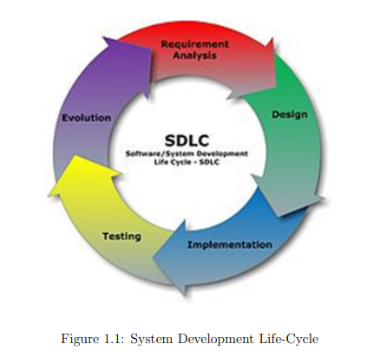In this step, you need to find out the organization’s objectives and the nature and scope of the problem under study.

Even if a problem refers only to a small segment of the organization itself then you need to find out what the objectives of the organization itself are.

Then you need to see how the problem being studied fits in with them.

**Propose alternative solutions:**

* Alternate proposals may come from interviewing employees, clients, suppliers, and/or consultants.
* You can also study what competitors are doing.
* With this data, you will have three choices: leave the system as is, improve it, or develop a new system.

**A software development process, also known as a software development life-cycle (SDLC), is a structure imposed on the development of a software product.**

**It aims to be the standard that defines all the tasks required for developing and maintaining software.**

**Requirement Analysis**

To perform this the complete problem has been divided into five sub-problems so that they can be solved easily and after that can be integrated.

Online Registration / Enrollment of Student

* Online Login.
* Online Schedule.
* Online Manage the question bank.
* Online Examination.
* Online Result declaration.

**The Functional Requirements are as follows :**

* To provide the functionality to students to appear for the exam online.
* To provide login interface through which only authorized user can pass by.
* The timer facility should be provide once the student appears in the Exam.
* The web application provide question to the student randomly.
* This system should handle multiple exam at the same time.
* It should functionally enable Expert to send set of Questions.

**The Non-Functional Requirements are as follows :**

* The system should be reliable and robust.
* It should be User friendly.
* It should be completely Consistent and Secure.
* Interface should be easy to follow with less graphics and should produce relevant error message.